MICRON OFI

Request: ASR 6155

SKH Outbound Summary Report – report summary by SO and Line item.

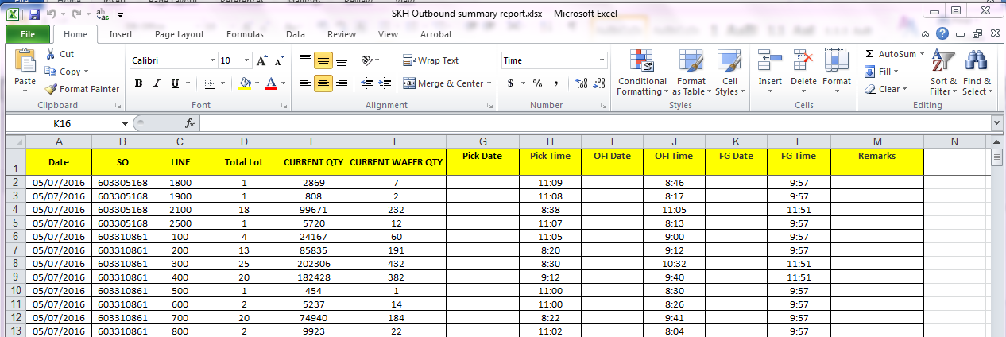

Date = Import date.

Pick date and time will be the picklist printed timing.

OFI date and time will be the will be the scan completed timing.

FG date and time keep it blank for our staff to input.

WMS Changes:

New report –

Daily Outbound Summary – by SO Line

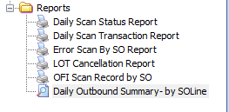

Report criteria:

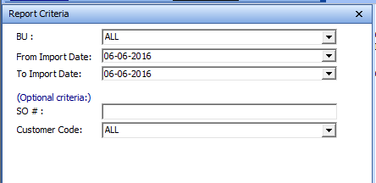

[sample]

